How to paint Einstein on the wall
This document is a popular science article, originally published by our store on Zhihu. The article introduces the principle of wall painting machine, which can help readers quickly understand the working principle of wall painting machine. But it is not an instruction for use. For specific assembly and program debugging, please read the "Wall Drawing Machine Installation and Debugging Instructions" document.

Question, why draw Einstein? In fact, painting people, animals, and landscapes are all the same. I just found a celebrity who catches the eye. Don't be more serious. Everyone is the same.

Speaking of wall paintings, did you think of these
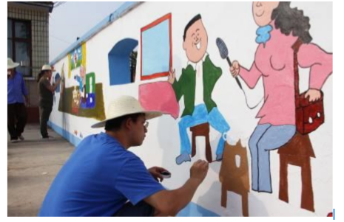
Back in 2002, two talented designers came up with a device called Hektor.
It is controlled by 2 motors and 2 ropes pull a self-painting, spray painting on the wall. Later, the equipment of this structure was widely spread in the maker circle. There are many names V Plotter Design, Polargraph, Wall Drawing Machine, Drawbot, etc. Anyway, it doesn’t matter what the name is, 2 motors and 2 ropes (there are also 4 motors, and there are also below Two, this structure can be placed flat on the ground), just drag a device that can draw lines and move it. The rope traction bracket moves on the wall and can be pulled to most areas of the wall (in fact, many positions are not reachable, and the best drawing area is a relatively small range.) There is another one that can control the pen down and lift Institutions, even if they can’t lift the pen and can only draw in one stroke, can they consider the crazy cursive calligraphy and painting mode, haha. The above is the part of its hardware working principle.

We need an Arduino or Raspberry Pi that can control the forward and reverse rotation of the motor, 51, STM32, PLC, whatever it is, just something that can control the rotation of the motor. I don’t know how to use any of them except Arduino, so. . . . . . In fact, their principles are similar, and there is not much difference in procedures.

Now that the prototype is available and the working principle is also understood, think about the successful Zotye Automobile. So what are we waiting for? Practice it, Sao Nian, don't wait. Let's start drawing Einstein.

The first step: Google downloads a picture of Einstein.
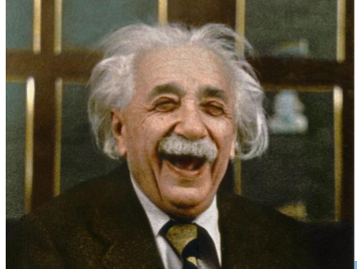
When encountering obstacles, it is really difficult at the beginning. We only have a continuous pen. Although it can be a colored pen, we can still only draw one color, so we need to find a monochrome photo. In fact, we can develop a 12-color pen holder, choose different colors of pens for painting, or even a 256-color pen holder. . . Stop dreaming, and do monochrome first. Multicolor is the fourth phase of the project (what is the second and third phase of the project? I haven't thought about it yet)

Step 2: Re-Goolge a monochrome Einstein
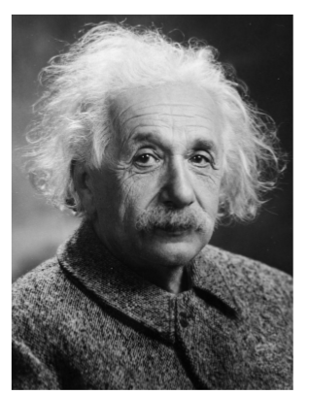
Wait, I have encountered difficulties again. Although the photo is black and white, there are still many different grays, dark grays, light grays, dark dark grays, and light light grays. . . . Obviously, our pen can't make strokes of different depths. (In fact, we can consider applying different pressures to the pen to make the painting feel like strokes. The pressure-sensitive screen can paint depth according to the intensity. The second phase of the project is available) So we need a pure black and white photo without gray. Step 3: Continue to Google a black and white Einstein.
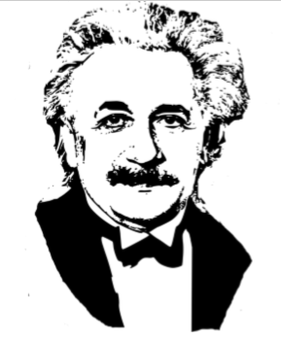
Well, I found the perfect black and white Einstein. Wait, what seems to be wrong? This person seems to be the godfather? keep searching.
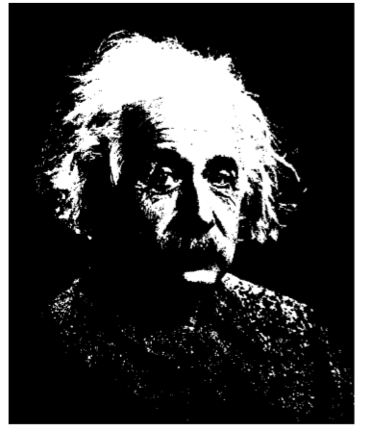
If I know PS, I don't have to be so troublesome. I think it should be like this, but unfortunately I won't continue to look for P.
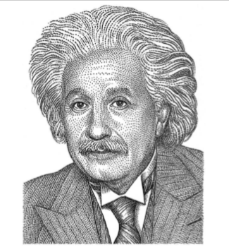
Perfectly found a black and white Einstein.
In the fourth step, the picture is a bitmap, which needs to be converted into a vector diagram before drawing.
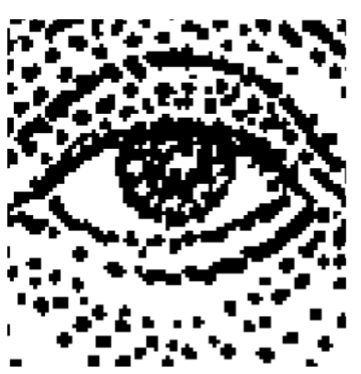
What is a bitmap, if you zoom in, it is an image composed of dots.
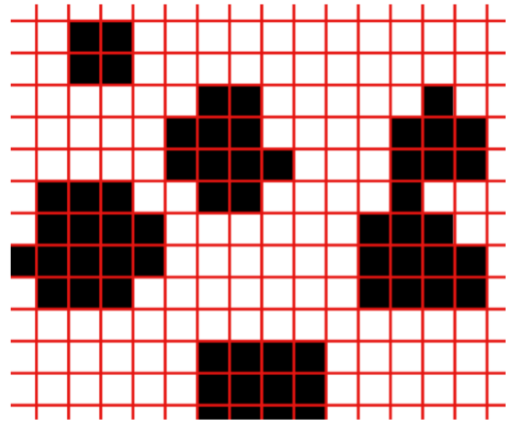
Zooming in again, each grid is a color, composed of many grids combined together to form a pattern. The simple Einstein above is composed of 799744 black and white grids with 781 horizontal * 1024 vertical. There are approximately 231,000 black dots. We can know the position of each black dot, and then use a pen to make a dot on the paper. Each point takes 63 hours to complete in 1 second, which seems a bit slow.
What is a vector illustration?
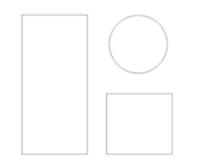
For some graphics or lines, use numbers to record the position, size, color, line thickness and other information of the graphics. Every time you see a picture, you are first calculated and then drawn (they are finally displayed on the screen as a dot matrix. The form is displayed). The advantage of this kind of graph is that it can be enlarged arbitrarily, no matter how big it is, it will not produce the kind of square points in the dot matrix graph. The disadvantage is that only relatively simple patterns can be displayed.
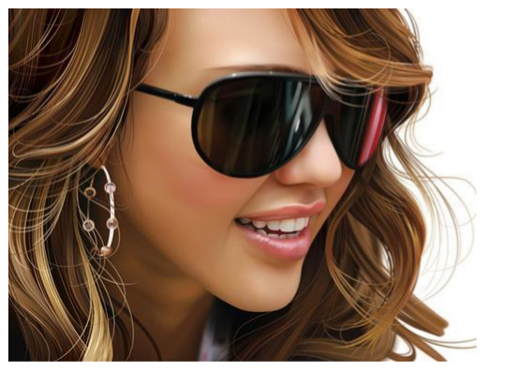
This is also a vector diagram, not simple at all. These are drawn by the great gods who have taken serious art classes (for example, art schools with only art classes but no culture classes) (don't think about it if we haven't taken art classes). One more sentence, vector diagrams are best at curves and can kill bitmaps in seconds. Each strand of hair in the above picture is a curve, and different colors can show amazing details. Pulled away. Pull back to Einstein, how to turn the bitmap into a vector diagram? Answer, yes, but not all pictures are possible. There are many kinds of software that can realize this function. We talk about a free software Inkscape. (You can go to its official website to download and use for free, of course, other paid software is also available)
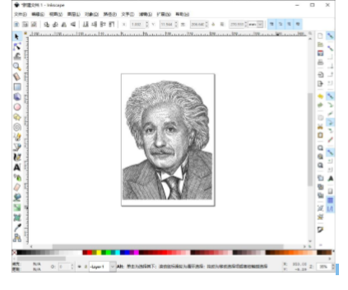
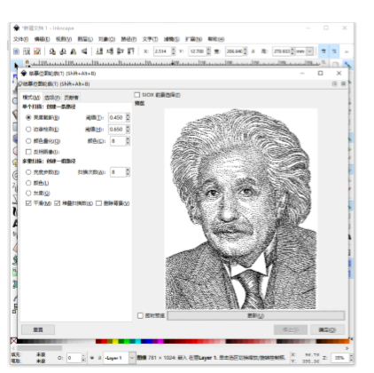
The operation is very simple, drag Einstein in, select Einstein, path -> copy the bitmap outline, and confirm.
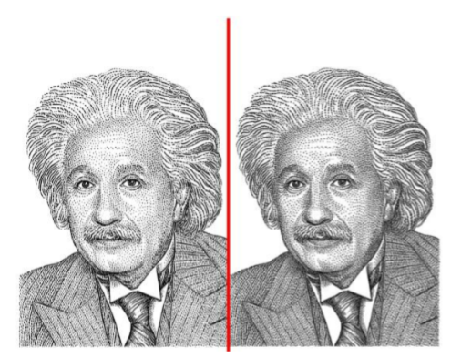
At first glance, it is impossible to distinguish who is a bitmap and who is a vector.
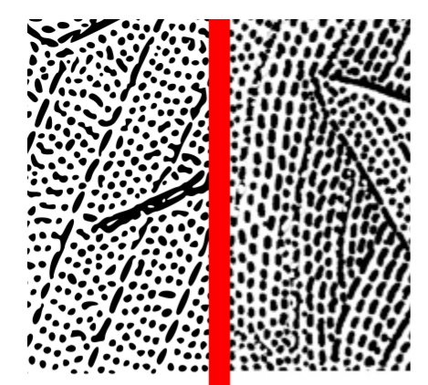
You can see some clues by zooming in to 200%.
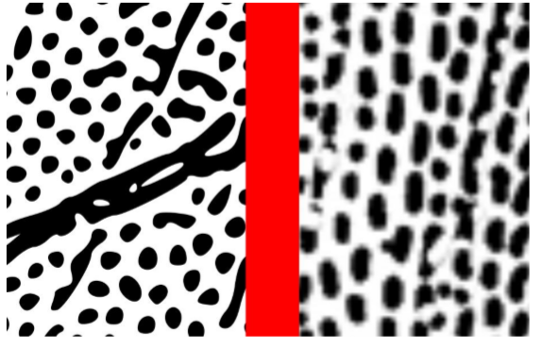
800% of the time, the bitmap is already terrible

The vector diagram can also continue to zoom in, zoom in, and zoom in again without pressure.
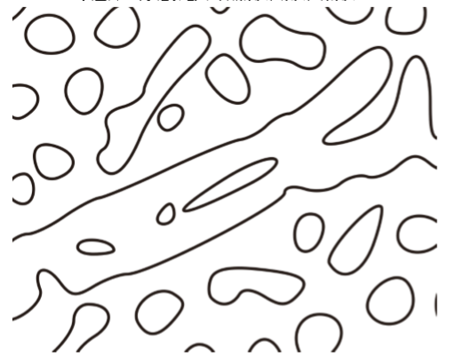
Let's ignore the coloring problem first. Let the pen follow these paths to draw the outline. If you want to fill in the color, go back and forth a few more times, just like a kid drawing. Stroke first, then fill in the color, and you're done. But we have powerful equipment that can be precisely controlled to draw multiple contours, each time indented by the width of one stroke to fill the color. Just let the pen move along the path I planned, and it can be drawn. These are not important, just a matter of time.
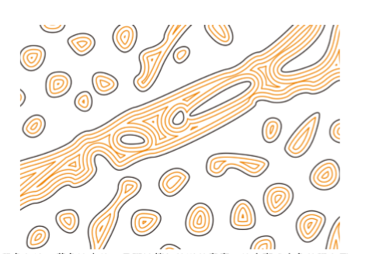
The black border, the yellow color is solid, as long as the width of the stroke is calculated, it will become a solid color pattern.
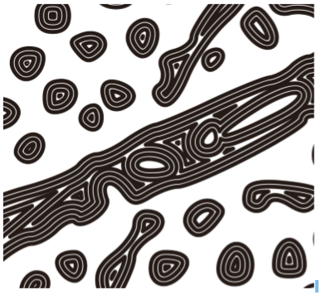
In fact, there is no difference between these two steps, they both let the wall painting machine take a specific path. So merge similar items and ignore the second step to reduce the workload. We only need to make an outline first. Mainly because of my intensive phobia, otherwise I can't continue.
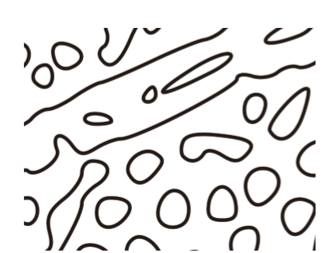
Next, you need to make something called G-code (G-code is the most widely used numerical control programming language in the world), which is to convert the path in the pattern into a series of position coordinates, and let the machine follow these coordinates a little bit A little movement can process the pattern we need. In layman's terms, it tells the machine to move x1, y1, x2, y2...Xn, Yn from coordinates xy. Do you think something is wrong? The horizontal and vertical straight lines can also be understood. How is the curve described? It seems to be a bitmap again, right? Yes, G-code is a bitmap. It just has a decimal point. There are almost no curves in Gcode, and any curve is split into small straight segments (avoid lever precision, some devices have a curve function, as long as the parameters of the curve are described, the machine can automatically operate according to the curve)
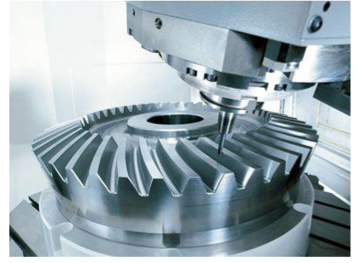
Even this German 5-axis CNC machining center also uses G-code, a variety of small straight lines! In fact, the calculation of G-code is also a very complicated process. It needs to calculate the acceleration, deceleration, inertia of various motors, the material of the workpiece to be processed, the size of the tool, the processing accuracy, speed and other factors. Precision machining centers can achieve micron-level movement control. What curve is needed for such high precision. . .
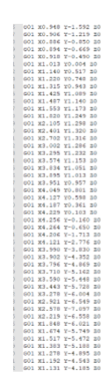
Pull it back, we are ok with millimeter accuracy. (In fact, our theoretical resolution can reach 0.027mm, even if the actual accuracy error is one order of magnitude, it can reach a resolution of 0.27mm, which is quite amazing) Just draw Einstein, completely crushed by force. Inkscape can make vector graphics into G-code and save them. There are many ways to ask Google to do it, but Baidu can do it. Omit here.

As above, we have completely transformed a photo into a series of position coordinates. We only need to let the equipment go to the position we specified accurately, and then to the next position, it is OK.

How to get to a predetermined location? We can study the topic.
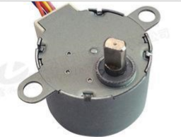
Stepper motor, please Google it. Simply put, it is a motor that can precisely control the rotation angle. Ordinary motors turn when energized. How much it turns can only be estimated, and cannot be accurately controlled. After a power failure, it cannot be held, and a large load will be pulled backwards. The stepper motor can not only accurately control the speed and angle (the minimum angle of an industrial stepper motor can reach 0.9°, and it can achieve higher precision with a reduction gear), but also can maintain a certain force when it is stationary (not Rotated by external force). We use a relatively well-controlled 28BYJ stepper motor with a reduction gear, which can meet our needs. Generally, the air deflector of the air conditioner is pulled by this kind of motor. After connecting the cable, we can use the program to control it, without additional drivers, power supplies and other inexplicable equipment. You don't need to know the subdivision and pitch angle of the stepper motor. . . And other inexplicable attributes. One line of code m1. Steps (1), turn it around. Circulate 2048 times and make one revolution. If a 35mm spool is used, one turn can pull the 0.027mm thread. It's that simple, even if the stepper motor is over.
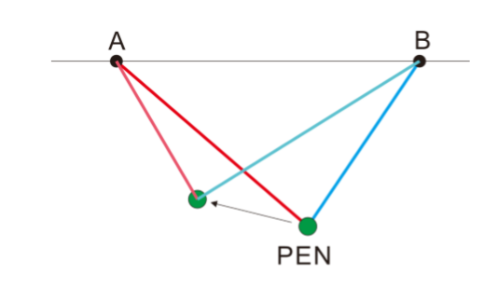
Next, let's see how the two wires pull the nib. When the two stepping motors are at point AB, the motor rotates the spool to retract and retract the two lines, and the pen will move accordingly. As long as the A motor pulls the wire and the B motor releases the wire, the pen can be moved to the desired position. It is easy to calculate how many distances and how many lines need to be placed. Learn about trigonometric functions?
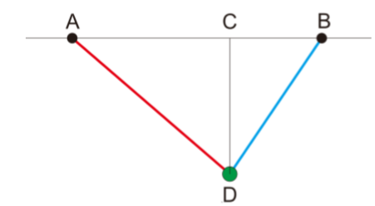
Knowing the length of the line segment AB, CD, find AD, BD? If you have forgotten, please ask a 14-year-old Sao Nian. Because I only remember that the art class was robbed by the math teacher, and I forgot everything in the class. Sao Nian told me that AD = √𝐴𝐶2 + 𝐶𝐷2 Pythagorean Theorem I learned in elementary school, and he almost forgot it.
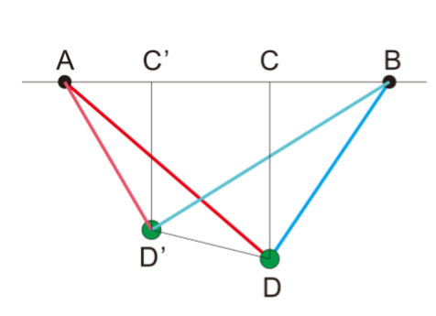
To move from D to D', you only need to calculate the difference between AD and AD', the difference between BD and BD', and then see how many wires are put in, how many wires are taken in, and calculate whether the motor should rotate forward or reverse and rotate. Step is OK. It's that simple.

Then we only need to read the G-code, move the pen line by line according to the coordinates, and in one click, we can draw Marlon Brando's godfather.
